Collaboration Online Judgement System Demo

**Overview:**

This web App is serves as a combination of “google docs” and “online judgement”. It supports collaboration coding for a specific question. After logging in to same session/question, users can see their collaboration coders in this session, and they can see each other’s actions immediately, just like google docs. Users can also search their problems by keywords and a problem list that include these keywords will show up.

After clicking submit button, a python server is served as an executor to execute the code that users submitted on Docker. The executor now supports Java and Python, which is easy to add more language using same methods. After that, users can see their results that shown at the bottom of the page.

I use MongoDB as my database to store all the coding problems. I also use Redis as in-memory store in order to save the session info and user info as cache. It will expire in one hour after the user disconnect from the server or close the webpage.

Nginx service is used as a reverse proxy for load balancing. It can protect the server when a huge amount of request is coming in. Right now, I’m using round-robin as the methods for load balancing.

**Demo:**

Main page:

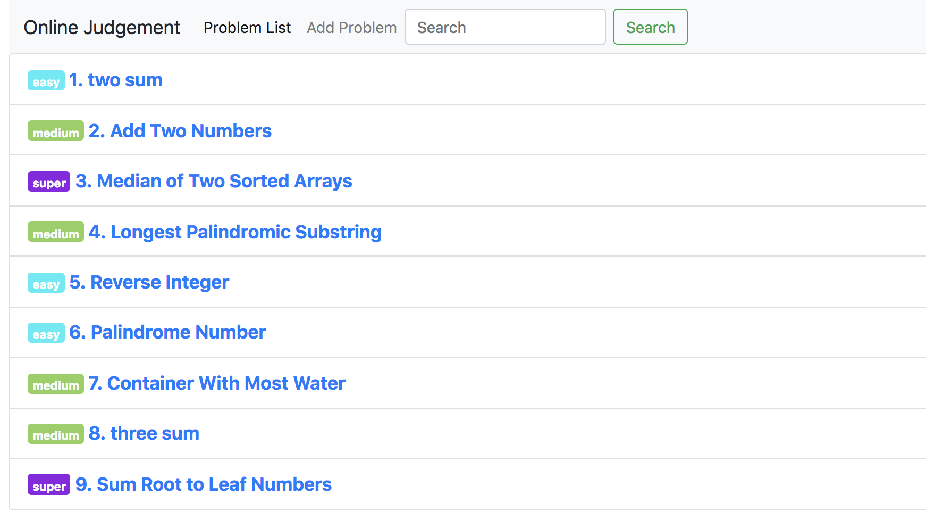

2. collaboration demo:

we can see that rught now there are couple users logging in, we can see their unique id at the bottom ( since its just random test users, their id is generated by socket with some UUID/GUID code)

once a coder is typing anything on the editor, all other coders in this session/problem will see the change immediately

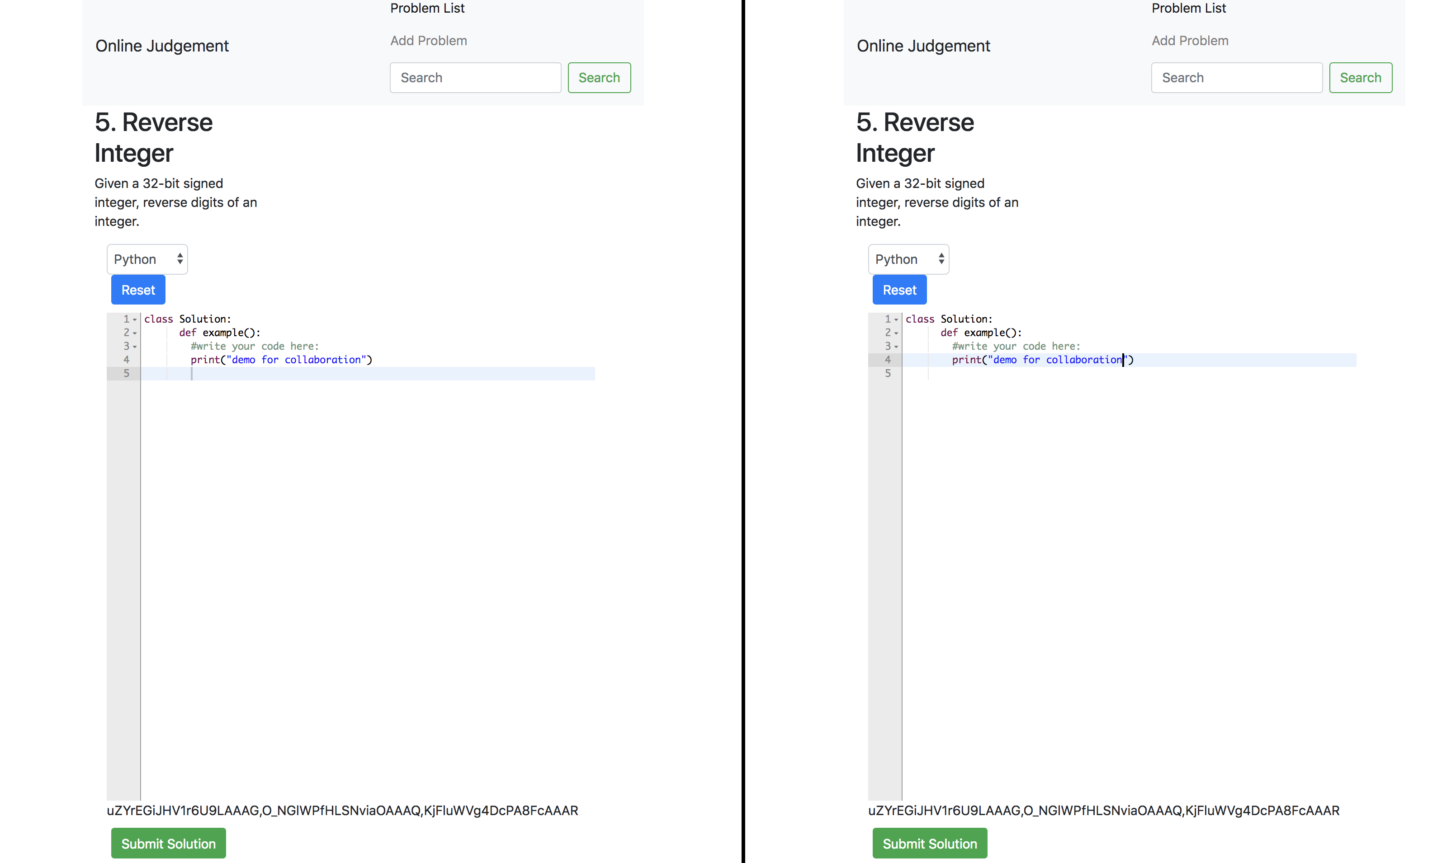

Once we click submit solution button, we can see the result at the bottom (I simply generate some errors)

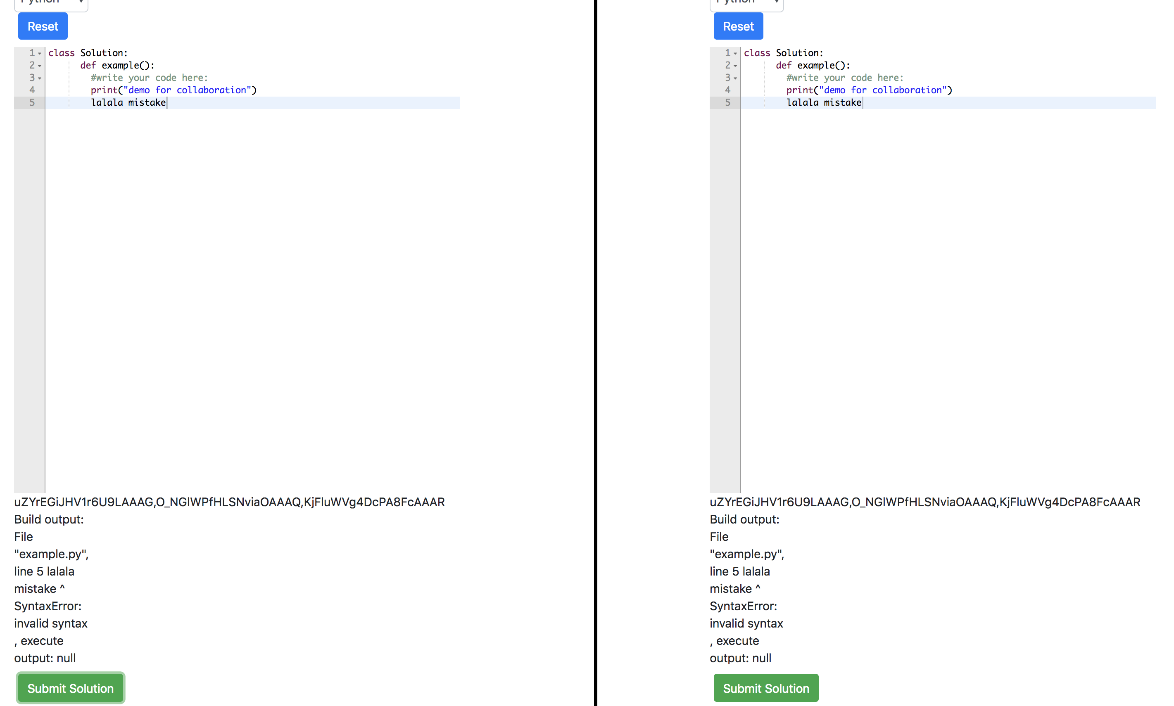

We can also use the search bar to search problems using keywords

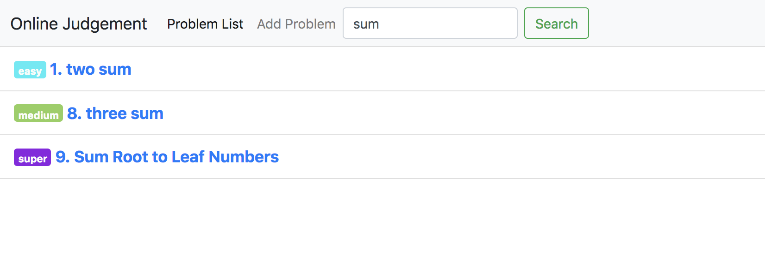

As an admin, I can also add questions to the problem list. Any save or change on this page done by admin will be update to MongoDB.

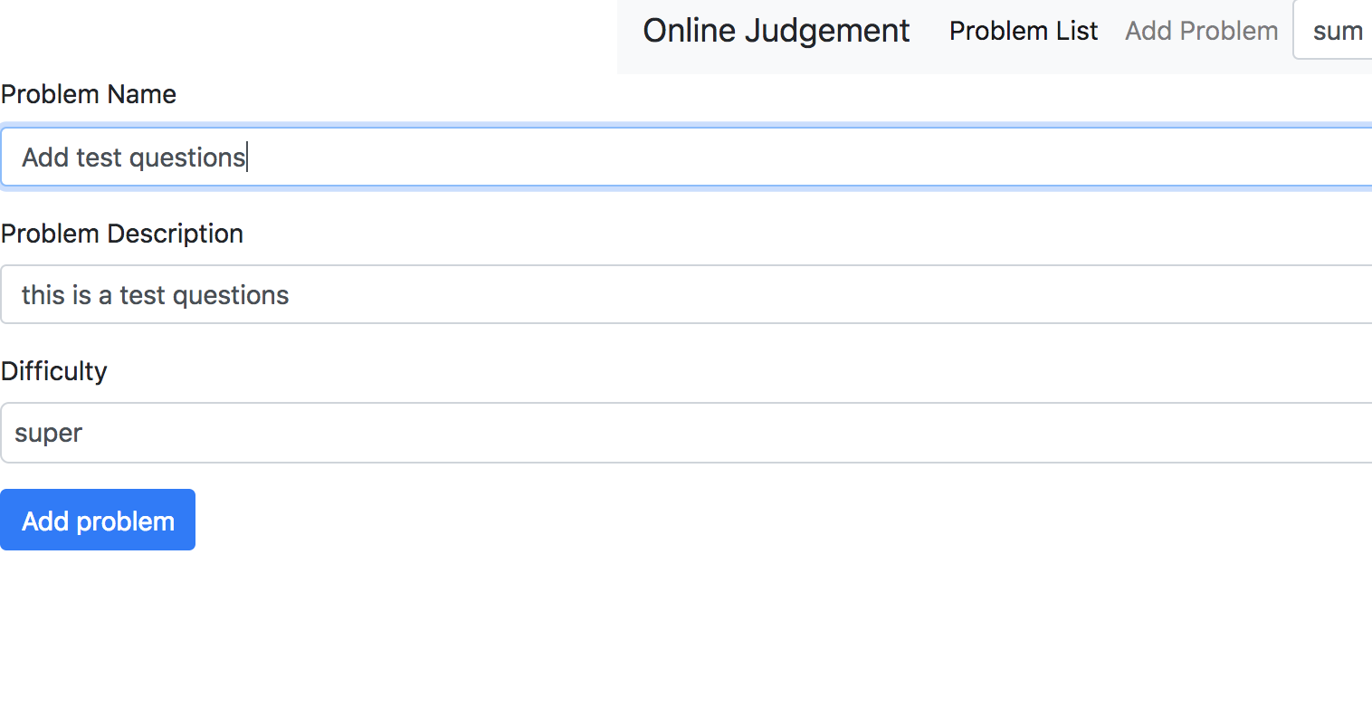

Successfully added

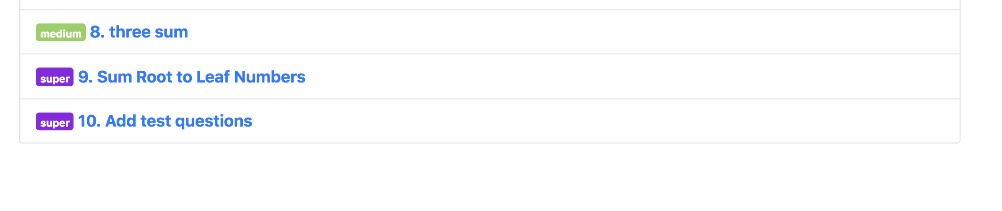

Database: (mLab)

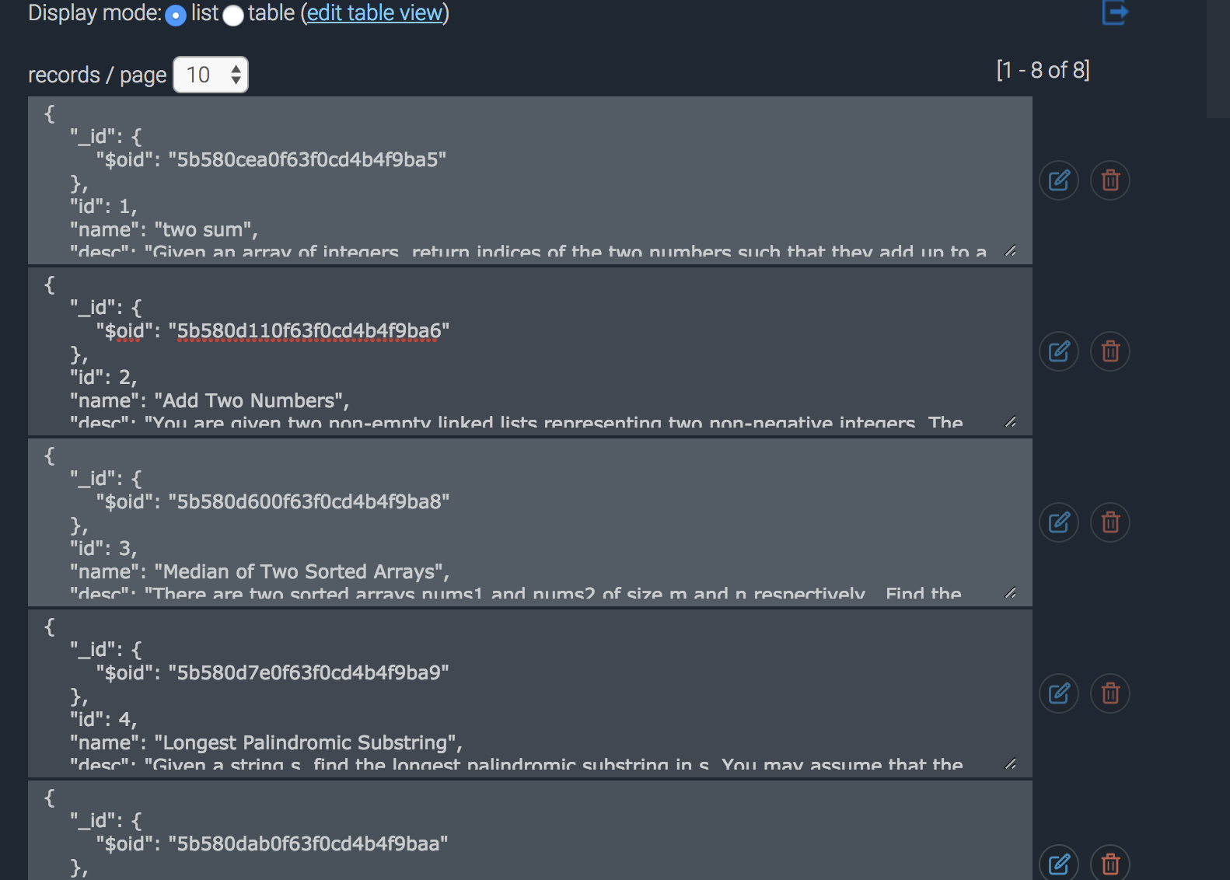

Thank you for watching! There is a readme file that shows how to play this app on localhost